# Introduction

Engine Exhaust Gas Temperature (EGT) is a key measure of the engine in terms of it’s maintenance cycle. As the engine wears down the seals around the fan blades, gas at a higher temperature is leaked from this gap. Engineers inspecting the engine measure this temperature and use an excel spread sheet issued by the manufacturer to determine when the next maintenance is due (or perhaps overdue)

# Application Flow

The “Landing page” of the application allows the user to find the history of a specific engine using it’s serial number or to find the history of an engine model or designation.

# Screen Mock-ups

## Landing Screen

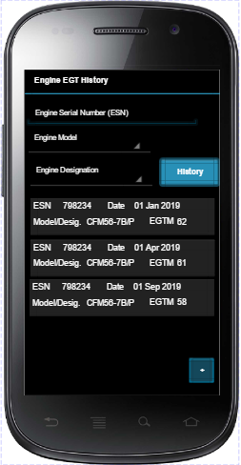

From this screen, the user will have the following options:

### History

If the user enters an Engine Serial Number, Engine Model and/or Designation and presses the History button, they will be presented with a series of cards showing the previous records of the entries selected. This will be in chronological order with the latest entry first.

If the user long presses on one of the cards, the EGT Result Dialog screen will be presented.

### Add new Entry

If the + button is pressed, a dialog screen will be presented to the user allowing them to record a new entry.

## Add New Entry

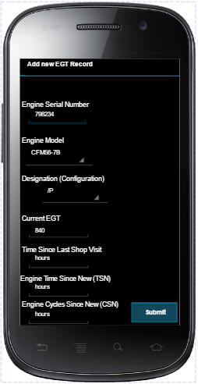

This screen allows the user to record a new Measurement for the engine and works as follows:

* User enters the Engine Serial number for the engine, If this serial number already has history then
  + The Engine Model is automatically recorded, if not the user must enter this
  + The Time Since Shop Visit is automatically recorded, again if not then user must enter this
* After the Engine Model is selected, the dropdown list for the Designation is populated for the selected engine model. The user selects the Designation that the engine is operating at. From this the system is able to determine the thrust
* The user now enters the following information having completed the exhaust gas test and captured the other values:
  + Current EGT
  + Time Since Last Shop Visit (if not already populated)
  + Engine Time Since New (TSN)  
    This is the flying hours of the engine
  + Engine Cycles Since New (CSN)  
    This is the number of take offs the engine has completed since new

Once all of these entries have been captured the user clicks on the Submit button, this in turn presents a new dialog to show the result.

## EGT Result Dialog

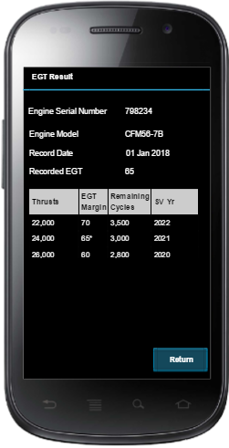

This Dialog screen will present the user with the results. Details of the Engine will be presented along with it’s current EGT margin (calculated by subtracting actual EGT from the red line limit) at the top and a table showing the possible thrusts this engine can operate at along with the associated EGT Margins are presented. Underneath the table, the Estimated Time to Shop Visit is presented.

The Return button will return the user to the landing page of the application in all cases.